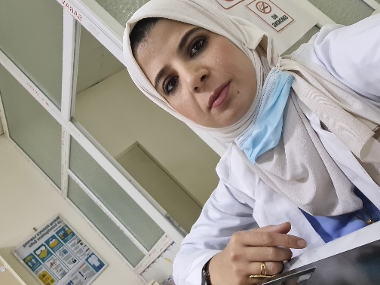  Personal Information  Afnan Saab Feihan  Date of birth: 1-9-1992  Nationality: Iraq  Gender: Female  Marital status: Single  Contact Info.  Address: Iraq/ Diyala / Al-Khalss  Phone/ WhatsApp:  009647737891688  Email:  afnansaab1992@gmail.com  afnanlabs@bauc14.edu.iq  Research gate:  https://www.researchgate.net/profile/Afnan-Saab  Google Scholar:  https://scholar.google.com/citations?user=FKom-L4AAAAJ&hl=en&authuser=1&citsig=AMD79or80mqMSkDjrxtjgtm7ToXsqCUJ_w  Orcid  https://orcid.org/0000-0001-8899-2822  LANGUAGES  Arabic ●●●●●  English ●●●◌◌ |  | WORK EXPERIENCE  1/2020- to present  Bilad Alrafidain University College/ Department Of Medical Labs Techniques  EDUCATION  2010 - 2019  Bachelor Degree, Department of Biology Science from the College of sceince, University of Diyala, Iraq  2013 - 2014  Master Degree, College of Science, Biology Department, University of Diyala, Iraq  RESEARCH FIELD  - Bacteriology, Genetic.  PUBLICATIONS  - Afnan S. Fehan, Kareem I. Mubarak. (2019). Detection Of Some Virulence Factors And Antibiotics Susceptibility Of Escherichia Coli Isolation From UTI Patients. Biochem. Cell. Arch. Vol 19, No 2, pp 4351-4356.

