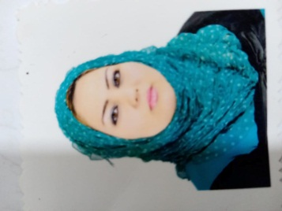
Personal Information  Name: Hiba Ahmed Iedan Yassin  Date of birth: 8\1\1990  Nationality: Iraq  Gender: Female  Marital status: Married  Driver license: Iraqi  Contact Info.  Address: Iraq – Diyala – Ba'qubah  Phone/ WhatsApp: +9647715541070  Email: ahmedhiba404@gmail.com  Research gate:  UGC journals: Journal@coehuman.uodiyala.edu.iq  LANGUAGES  Arabic●●●●●  English ●●●●● |  | WORK EXPERIENCE  Responsibilities:  Experience:  1- teaching English Language for the students of the 6th preparatory for 10 years.  2- Teaching at college of Bilad Al-Rafdain for a year.  EDUCATION  - BA (University of Diyala \ College of Education for Humanities \ Department of English) (2010 – 2011)  - MA: specialized in Linguistics (University of Diyala \ College of Education for Humanities \ Department of English) (2020)  SKILLS  .  Certifications  Certificate of participation from Garnet organization in Lebanon.  PUBLICATIONS

