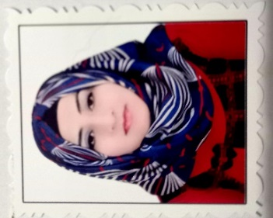  Personal Information  Rusul Kareem Ismail  Date of birth: 2-3-1990  Nationality: Iraq  Gender: Female  Marital status: Single  Driver license: Iraqi  H-Index 1  Contact Info.  Address: : Iraq/ Diyala /Baqubah  Phone/ WhatsApp:  009647713252061  Email:  drRusul@bauc14.edu.iq  rusulkareemismail@gmail.com  Research gate:  https://myaccount.google.com/personal-info  Google Scholar:  https://scholar.google.com/citations?user=Os420bkAAAAJ&hl=ar  Scopus:  https://id.elsevier.com/settings/redirect?code=RiFPVB1duGMecCc21mBhaw1R5wP9GjJktLkea-Li  Publons:  https://publons.com/researcher/4797546/drrusul/  Orcid  https://orcid.org/0000-0002-7637-8638  LANGUAGES  Arabic ●●●●●  English ●●●●◌ |  | WORK EXPERIENCE  01/2016 – 07/2016  laboratory Assistant in University of Diyala/College of science/ / Department of Physics Science  1/2020- to present  Bilad Alrafidain University College/ Department of Radiological Techniques  EDUCATION  2008 - 2012  Bachelor Degree, Department of Physics Science / College of science /University of Diyala  2013 - 2015  Master Degree, Solid State and Material Physics / Department of Physics Science/ College of Science/ University of Diyala.  2016-2020  Ph.D. Degree, General Physics / Department of Physics Science/ College of Science/ University of Diyala.  SKILLS  - Microsoft Office.  - Internet  - Origin.  - J-image  - Work on laboratory (physics [medical and general]  RESEARCH FIELD  - Nanotechnology  - Physics solid state /Material  - Thin films  - Cell Lines  PUBLICATIONS  - Sabah A. Salman, Ziad T. Khodair and Rusul K. Ismail," Study The Effect of Thickness on The Optical Properties of Znfe2o4 Films Prepared By Chemical Spray Pyrolysis Method" International Journal of Current Research, Vol. 6, Issue, 11, pp.9669-9675, November, (2014).  - Sabah A. Salman, Nabeel A. Bakr and Rusul K. Ismail, "Study of the Effect of Annealing on Optical Properties of ZnFe₂O₄ Films Prepared by Chemical Spray Pyrolysis Method", Int. J. Thin. Fil. Sci. Tec. 5, No. 1, pp. 33-37, (2016).  - Rusul k. Ismail, Raad M. S. Al-Haddad and Tahseen H. Mubarak, "Time Effect on the Red Shift of Surface Plasmonic Resonance Core-Shell SiO₂: Gold Nanoparticles (AuNPs)", IP Conference Proceedings 2190, pp. 1-6, (2019).  - Rusul k. Ismail, Tahseen H. Mubarak and Raad M. S. Al-Haddad Surface Plasmon Resonance of Silver Nanoparticles: Synthesis, Ch3aracterization and Applications, J Biochem Tech, 10 (2), pp. 62-64, (2019).

